Ministry Category: **Government of Chandigarh**

Sector: **Education & Skills**

Problem statement:

**Predictive Student Analysis**

**This might include an in depth look at the psychometric and performance analysis of the students through online system that analyses the students’ data to identify students on the verge of dropping out of college and allowing college to take corrective measures to ensure students remain in college. All the students and teachers teaching the students would be required to fill online questionnaire at regular intervals (after every three months/twice in a semester) The analysis would also incorporate Teacher’s Feedback regarding individual student for complete profiling and based on the class/academic performance would predict what grade students will receive. The analysis would also match students with courses and specialisations they are most likely to do well in Post- Graduation.**

Team Leader: **Sachin Yadav**

Problem Code**: #GCH1**

College Code: **#7892**

**Approach**

S-Student

T-Teacher

1. **Filling the questionnaire/ Gathering the data:**

* **All the students are required to fill the questionnaire on the college/university portal. The questionnaire would contain questions from:**

1. Standard psychometric test
2. Personality test
3. Reflection/feedback

* **Questions would be multiple-choice/discrete in format. For example**

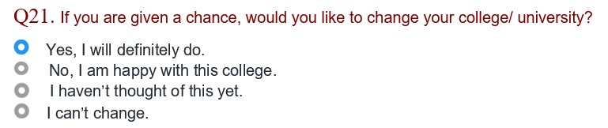

* **Teacher’s feedback about the particular student:**

Questions about his attendance, behaviour, assignment submission, etc.

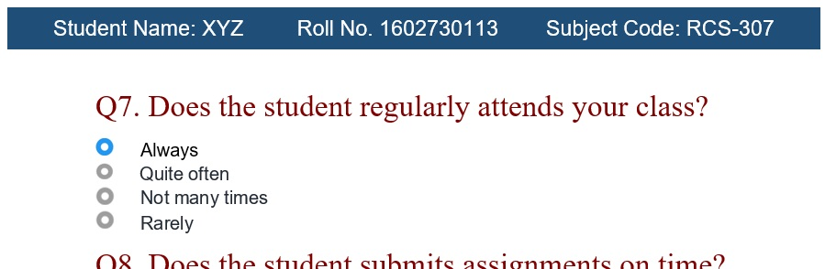

* **Other details of students are required:**

1. Grades(marks) in various exams, assignments, etc.
2. Entrance test score or ranking.
3. Attendance
4. Courses opted

**Stage 1:** **Gathering the data**

S- Student
T - Teacher


1. **Pre-processing of data and Model Training:**

* **Feature extraction and generating new features:**
  + 1. Particular features are extracted from the available data for a particular problem.
    2. New features are generated from selected features.
* **Opting Machine Learning Algorithm for suitable model:**

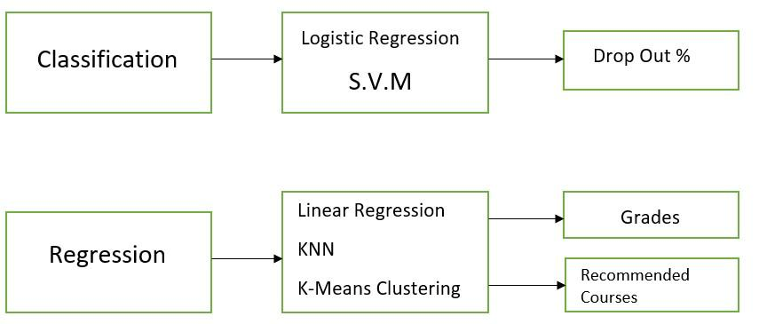

* **Training of Model:**
  + 1. Machine learning model is trained on the available data set.
    2. Performance of the model improves with training.
    3. Confidence scores are calculated.

1. **Predicting Results and Further Analysis:**

* **Prediction about dropout %, grades and recommended courses by applying the trained model on data.**
* **Statistical analysis is done on the predicted results and also on the available data as the part of student’s assessment.**
* **Final results are stored and would used to generate assessment report.**

**Stage 3:** **Prediction and Analysis**

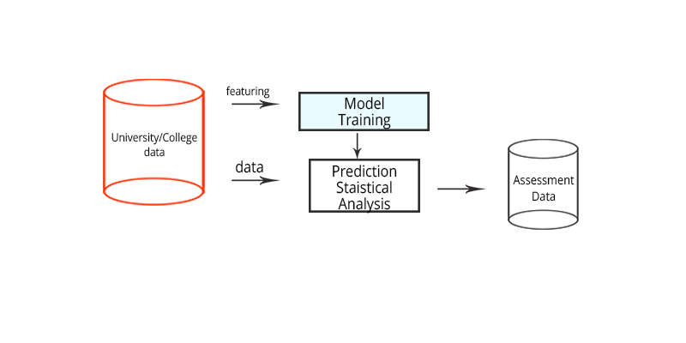

1. **Make the assessment data available to students and teachers:**

* **A report based on assessment data (predicted results + statistical analysis) would be generated for every student.**
* **The report will display data using visualisation like graphs and charts:**

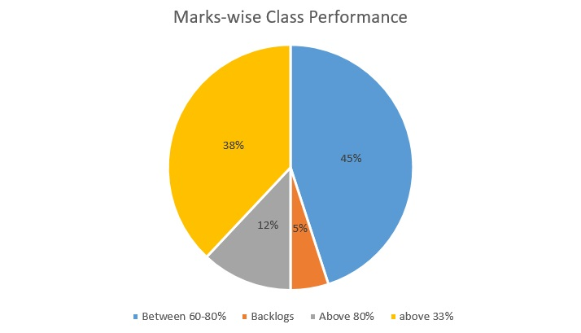 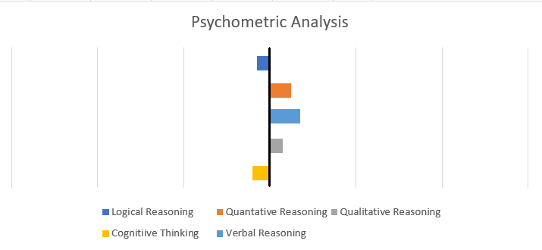 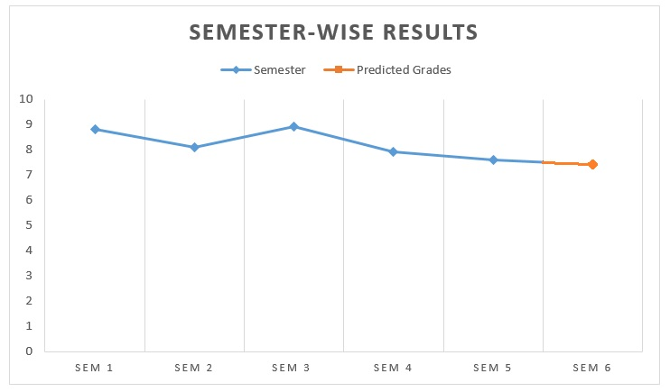

**Stage 4:** **Reporting**

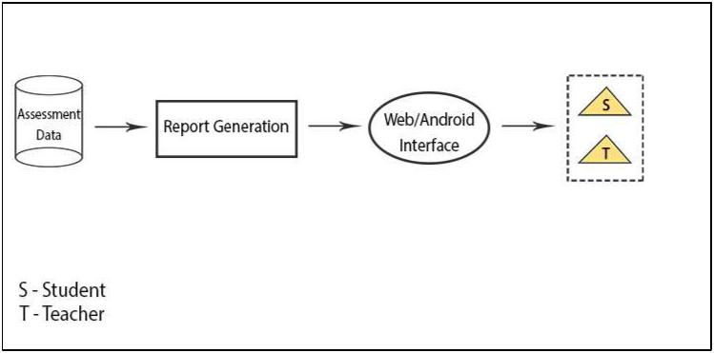

1. **Validating the predicted result against actual result:**

* **At the end of the semester, actual data regarding grades, dropouts, etc would be stored in the college/university database.**
* **This data would serve as the training data for improving the performance of the model.**

**SUMMARY**

**7.**

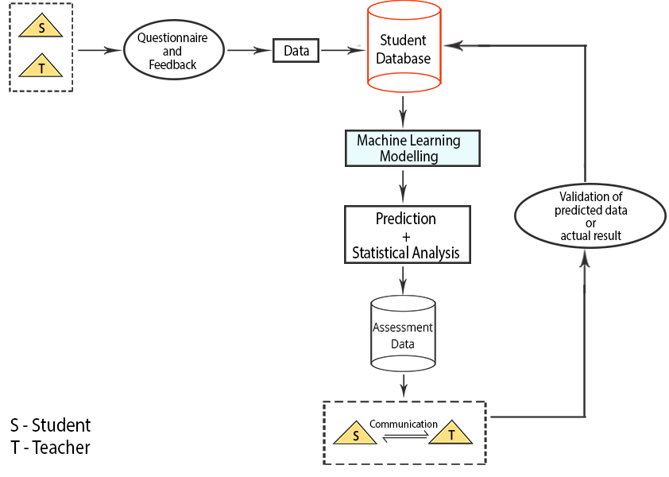

**Technologies Stack**

* **Programming: Python, php, Android**
* **Database: MYSQL/Oracle/MSSQL**
* **Machine Learning Models: Regression & Classification Models**

**Use Cases**

1. **This approach can help the college authorities to identify the students that are on the verge of dropping out. The authorities and teachers can take requisite actions to help such students.**
2. **This analysis would help to design appropriate coursework for students according to their needs and abilities.**
3. **This assessment would help students to improve their academic scores by identifying their weaknesses, strengths.**
4. **The predicted results would also help students in opting future courses accordingly. Thus helping them to study subjects for their choices and motivating them to perform better.**
5. **This approach can also be implemented at schools to better assess young children. Thus allowing them more time to build their abilities according to their interests.**

**Dependencies**

1. **Students’ Profile Data from college/university database.**
2. **Questionnaire and feedback filled by students and teachers.**
3. **Computing power for data processing.**